**// Subroutine : UpdateButtonClick_DESIGN_COLLARS()**

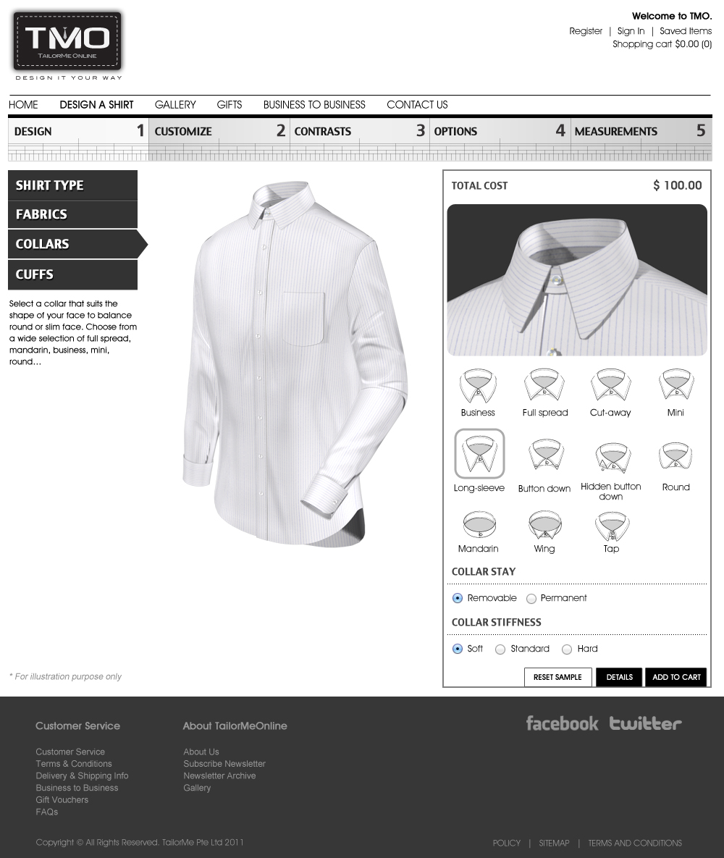

// Siva, please note that ‘Collar Height’ in the menu on the right has been added in the image above (previously missed out)

//----------------------------------------------- Collar

Upon clicking “Business”:

CollarLyr04[3] = “Classic-Inner.”;

CollarLyr05[3] = “Classic-Outer.”;

CollarLyr06[3] = “Classic-Thread.”;

CollarLyr07[3] = “Classic-Button.”;

ShirtLyr08[3] = “Classic-Inner.”;

ShirtLyr09[3] = “Classic-Outer.”;

ShirtLyr10[3] = “Classic-Thread.”;

ShirtLyr11[3] = “Classic-Button.”;

Call Subroutine : RefreshFilenames();

Call Subroutine : DisplayCollar(); // This updates the collar window

Call Subroutine : DisplayFullview(); // This updates the full shirt window

Upon clicking “Full spread”:

CollarLyr04[3] = “Fullspread-Inner.”;

CollarLyr05[3] = “Fullspread-Outer.”;

CollarLyr06[3] = “Fullspread-Thread.”;

CollarLyr07[3] = “Fullspread-Button.”;

ShirtLyr08[3] = “Fullspread-Inner.”;

ShirtLyr09[3] = “Fullspread-Outer.”;

ShirtLyr10[3] = “Fullspread-Thread.”;

ShirtLyr11[3] = “Fullspread-Button.”;

If (CollarLyr04[2] == “Low”) // “Low” disabled for this

CollarLyr04[2] = “Norm”;

CollarLyr05[2] = “Norm”;

CollarLyr06[2] = “Norm”;

CollarLyr07[2] = “Norm”;

ShirtLyr08[2] = “Collar-Norm”;

ShirtLyr09[2] = “Collar-Norm”;

ShirtLyr10[2] = “Collar-Norm”;

ShirtLyr11[2] = “Collar-Norm”;

Set toggle button at COLLAR HEIGHT to “Normal”

Call Subroutine : RefreshFilenames();

Call Subroutine : DisplayCollar(); // This updates the collar window

Call Subroutine : DisplayFullview(); // This updates the full shirt window

Upon clicking “Cut-away”:

CollarLyr04[3] = “Cutaway-Inner.”;

CollarLyr05[3] = “Cutaway-Outer.”;

CollarLyr06[3] = “Cutaway-Thread.”;

CollarLyr07[3] = “Cutaway-Button.”;

ShirtLyr08[3] = “Cutaway-Inner.”;

ShirtLyr09[3] = “Cutaway-Outer.”;

ShirtLyr10[3] = “Cutaway-Thread.”;

ShirtLyr11[3] = “Cutaway-Button.”;

If (CollarLyr04[2] == “Low”) // “Low” disabled for this

CollarLyr04[2] = “Norm”;

CollarLyr05[2] = “Norm”;

CollarLyr06[2] = “Norm”;

CollarLyr07[2] = “Norm”;

ShirtLyr08[2] = “Collar-Norm”;

ShirtLyr09[2] = “Collar-Norm”;

ShirtLyr10[2] = “Collar-Norm”;

ShirtLyr11[2] = “Collar-Norm”;

Set toggle button at COLLAR HEIGHT to “Normal”

Call Subroutine : RefreshFilenames();

Call Subroutine : DisplayCollar(); // This updates the collar window

Call Subroutine : DisplayFullview(); // This updates the full shirt window

Upon clicking “Mini”:

CollarLyr04[3] = “Mini-Inner.”;

CollarLyr05[3] = “Mini-Outer.”;

CollarLyr06[3] = “Mini-Thread.”;

CollarLyr07[3] = “Mini-Button.”;

ShirtLyr08[3] = “Mini-Inner.”;

ShirtLyr09[3] = “Mini-Outer.”;

ShirtLyr10[3] = “Mini-Thread.”;

ShirtLyr11[3] = “Mini-Button.”;

If (CollarLyr04[2] == “Low”) OR (CollarLyr04[2] == “High”) // “Low” & “High” disabled for this

CollarLyr04[2] = “Norm”;

CollarLyr05[2] = “Norm”;

CollarLyr06[2] = “Norm”;

CollarLyr07[2] = “Norm”;

ShirtLyr08[2] = “Collar-Norm”;

ShirtLyr09[2] = “Collar-Norm”;

ShirtLyr10[2] = “Collar-Norm”;

ShirtLyr11[2] = “Collar-Norm”;

Set toggle button at COLLAR HEIGHT to “Normal”

Call Subroutine : RefreshFilenames();

Call Subroutine : DisplayCollar(); // This updates the collar window

Call Subroutine : DisplayFullview(); // This updates the full shirt window

Upon clicking “Long-sleeve”:

CollarLyr04[3] = “LongSleeve-Inner.”;

CollarLyr05[3] = “LongSleeve-Outer.”;

CollarLyr06[3] = “LongSleeve-Thread.”;

CollarLyr07[3] = “LongSleeve-Button.”;

ShirtLyr08[3] = “LongSleeve-Inner.”;

ShirtLyr09[3] = “LongSleeve-Outer.”;

ShirtLyr10[3] = “LongSleeve-Thread.”;

ShirtLyr11[3] = “LongSleeve-Button.”;

If (CollarLyr04[2] == “Low”) // “Low” disabled for this

CollarLyr04[2] = “Norm”;

CollarLyr05[2] = “Norm”;

CollarLyr06[2] = “Norm”;

CollarLyr07[2] = “Norm”;

ShirtLyr08[2] = “Collar-Norm”;

ShirtLyr09[2] = “Collar-Norm”;

ShirtLyr10[2] = “Collar-Norm”;

ShirtLyr11[2] = “Collar-Norm”;

Set toggle button at COLLAR HEIGHT to “Normal”

Call Subroutine : RefreshFilenames();

Call Subroutine : DisplayCollar(); // This updates the collar window

Call Subroutine : DisplayFullview(); // This updates the full shirt window

Upon clicking “Button down”:

CollarLyr04[3] = “ButtonDown-Inner.”;

CollarLyr05[3] = “ButtonDown-Outer.”;

CollarLyr06[3] = “ButtonDown-Thread.”;

CollarLyr07[3] = “ButtonDown-Button.”;

ShirtLyr08[3] = “ButtonDown-Inner.”;

ShirtLyr09[3] = “ButtonDown-Outer.”;

ShirtLyr10[3] = “ButtonDown-Thread.”;

ShirtLyr11[3] = “ButtonDown-Button.”;

Call Subroutine : RefreshFilenames();

Call Subroutine : DisplayCollar(); // This updates the collar window

Call Subroutine : DisplayFullview(); // This updates the full shirt window

Upon clicking “Hidden button down”:

CollarLyr04[3] = “HiddenButton-Inner.”;

CollarLyr05[3] = “HiddenButton-Outer.”;

CollarLyr06[3] = “HiddenButton-Thread.”;

CollarLyr07[3] = “HiddenButton-Button.”;

ShirtLyr08[3] = “HiddenButton-Inner.”;

ShirtLyr09[3] = “HiddenButton-Outer.”;

ShirtLyr10[3] = “HiddenButton-Thread.”;

ShirtLyr11[3] = “HiddenButton-Button.”;

Call Subroutine : RefreshFilenames();

Call Subroutine : DisplayCollar(); // This updates the collar window

Call Subroutine : DisplayFullview(); // This updates the full shirt window

Upon clicking “Round”: // Siva, I’ll check if the icon pic is missing from the materials we passed you. Will email you later if so.

CollarLyr04[3] = “Rounded-Inner.”;

CollarLyr05[3] = “Rounded-Outer.”;

CollarLyr06[3] = “Rounded-Thread.”;

CollarLyr07[3] = “Rounded-Button.”;

ShirtLyr08[3] = “Rounded-Inner.”;

ShirtLyr09[3] = “Rounded-Outer.”;

ShirtLyr10[3] = “Rounded-Thread.”;

ShirtLyr11[3] = “Rounded-Button.”;

If (CollarLyr04[2] == “Low”) OR (CollarLyr04[2] == “High”) // “Low” & “High” disabled for this

CollarLyr04[2] = “Norm”;

CollarLyr05[2] = “Norm”;

CollarLyr06[2] = “Norm”;

CollarLyr07[2] = “Norm”;

ShirtLyr08[2] = “Collar-Norm”;

ShirtLyr09[2] = “Collar-Norm”;

ShirtLyr10[2] = “Collar-Norm”;

ShirtLyr11[2] = “Collar-Norm”;

Set toggle button at COLLAR HEIGHT to “Normal”

Call Subroutine : RefreshFilenames();

Call Subroutine : DisplayCollar(); // This updates the collar window

Call Subroutine : DisplayFullview(); // This updates the full shirt window

Upon clicking “Mandarin”:

CollarLyr04[2] = “Norm”;

CollarLyr05[2] = “Norm”;

CollarLyr06[2] = “Norm”;

CollarLyr07[2] = “Norm”;

CollarLyr04[3] = “Mao-Inner.”;

CollarLyr05[3] = “Mao-Outer.”;

CollarLyr06[3] = “Mao-Thread.”;

CollarLyr07[3] = “Mao-Button.”;

ShirtLyr08[2] = “Collar-Norm”;

ShirtLyr09[2] = “Collar-Norm”;

ShirtLyr10[2] = “Collar-Norm”;

ShirtLyr11[2] = “Collar-Norm”;

ShirtLyr08[3] = “Mao-Inner.”;

ShirtLyr09[3] = “Mao-Outer.”;

ShirtLyr10[3] = “Mao-Thread.”;

ShirtLyr11[3] = “Mao-Button.”;

Call Subroutine : RefreshFilenames();

Call Subroutine : DisplayCollar(); // This updates the collar window

Call Subroutine : DisplayFullview(); // This updates the full shirt window

Set the toggle button at Collar Height to “Normal” // Mandarin can only go with normal height

Upon clicking “Wing”:

CollarLyr04[2] = “Norm”;

CollarLyr05[2] = “Norm”;

CollarLyr06[2] = “Norm”;

CollarLyr07[2] = “Norm”;

CollarLyr04[3] = “Wing-Inner.”;

CollarLyr05[3] = “Wing-Outer.”;

CollarLyr06[3] = “Wing-Thread.”;

CollarLyr07[3] = “Wing-Button.”;

ShirtLyr08[2] = “Collar-Norm”;

ShirtLyr09[2] = “Collar-Norm”;

ShirtLyr10[2] = “Collar-Norm”;

ShirtLyr11[2] = “Collar-Norm”;

ShirtLyr08[3] = “Wing-Inner.”;

ShirtLyr09[3] = “Wing-Outer.”;

ShirtLyr10[3] = “Wing-Thread.”;

ShirtLyr11[3] = “Wing-Button.”;

Call Subroutine : RefreshFilenames();

Call Subroutine : DisplayCollar(); // This updates the collar window

Call Subroutine : DisplayFullview(); // This updates the full shirt window

Set the toggle button at Collar Height to “Normal” // Wing collar can only go with normal height

Upon clicking “Tap”:

CollarLyr04[2] = “Norm”;

CollarLyr05[2] = “Norm”;

CollarLyr06[2] = “Norm”;

CollarLyr07[2] = “Norm”;

CollarLyr04[3] = “Tap-Inner.”;

CollarLyr05[3] = “Tap-Outer.”;

CollarLyr06[3] = “Tap-Thread.”;

CollarLyr07[3] = “Tap-Button.”;

ShirtLyr08[2] = “Collar-Norm”;

ShirtLyr09[2] = “Collar-Norm”;

ShirtLyr10[2] = “Collar-Norm”;

ShirtLyr11[2] = “Collar-Norm”;

ShirtLyr08[3] = “Tap-Inner.”;

ShirtLyr09[3] = “Tap-Outer.”;

ShirtLyr10[3] = “Tap-Thread.”;

ShirtLyr11[3] = “Tap-Button.”;

Call Subroutine : RefreshFilenames();

Call Subroutine : DisplayCollar(); // This updates the collar window

Call Subroutine : DisplayFullview(); // This updates the full shirt window

Set the toggle button at Collar Height to “Normal” // Tap collar can only go with normal height

//----------------------------------------------- Collar Height

Upon clicking “Low”:

If (CollarLyr04[3] != “Mao-Inner.”) && (CollarLyr04[3] != “Tap-Inner.”) && (CollarLyr04[3] != “Wing-Inner.”)

CollarLyr04[2] = “Low”;

CollarLyr05[2] = “Low”;

CollarLyr06[2] = “Low”;

CollarLyr07[2] = “Low”;

ShirtLyr08[2] = “Collar-Low”;

ShirtLyr09[2] = “Collar-Low”;

ShirtLyr10[2] = “Collar-Low”;

ShirtLyr11[2] = “Collar-Low”;

Call Subroutine : RefreshFilenames();

Call Subroutine : DisplayCollar(); // This updates the collar window

Call Subroutine : DisplayFullview(); // This updates the full shirt window

Else

Set the toggle button at Collar Height to “Normal” // The above 3 types of collars must be normal height

Upon clicking “Normal”:

CollarLyr04[2] = “Norm”;

CollarLyr05[2] = “Norm”;

CollarLyr06[2] = “Norm”;

CollarLyr07[2] = “Norm”;

ShirtLyr08[2] = “Collar-Norm”;

ShirtLyr09[2] = “Collar-Norm”;

ShirtLyr10[2] = “Collar-Norm”;

ShirtLyr11[2] = “Collar-Norm”;

Call Subroutine : RefreshFilenames();

Call Subroutine : DisplayCollar(); // This updates the collar window

Call Subroutine : DisplayFullview(); // This updates the full shirt window

Upon clicking “High”:

If (CollarLyr04[3] != “Mao-Inner.”) && (CollarLyr04[3] != “Tap-Inner.”) && (CollarLyr04[3] != “Wing-Inner.”)

CollarLyr04[2] = “High”;

CollarLyr05[2] = “High”;

CollarLyr06[2] = “High”;

CollarLyr07[2] = “High”;

ShirtLyr08[2] = “Collar-High”;

ShirtLyr09[2] = “Collar-High”;

ShirtLyr10[2] = “Collar-High”;

ShirtLyr11[2] = “Collar-High”;

Call Subroutine : RefreshFilenames();

Call Subroutine : DisplayCollar(); // This updates the collar window

Call Subroutine : DisplayFullview(); // This updates the full shirt window

Else

Set the toggle button at Collar Height to “Normal” // The above 3 types of collars must be normal height

//----------------------------------------------- Collar Stay

This has no effect to the display

//----------------------------------------------- Collar Stiffness

This has no effect to the display

**// End of Subroutine : UpdateButtonClick_DESIGN_ COLLARS()**